Development Week 1

Tuesday, December 4, 2018

9:35 AM

**Tuesday**

**Issues**

* There are location records in the client collection (resolved)
* There is a test clients in production

**Tables Moved Into MSTR**

* Clients.txt
* Licences.txt
* Players.txt
* Locations.txt
* Subscriptions.txt
* ClientPrograms.txt
* ProgramVersions.txt

**Misc Tasks**

* Configured Pipeline

-------

**Wednesday**

**Issues**

* Documents in the players collection do not follow data standards or schema
  + E.g. Lg-22421, Lg-23064, Lg-SCOTT
* Documents in the locations collection do not follow data standards or schema
  + E.g. Integration Test Location, Unit Test-Location

**Tables Moved Into STD**

* Std.mstr_clients
* Std.mstr_licenses
* Std.mstr_players
* Std.mstr_locations
* Std.mstr_subscriptions
* Std.mstr_clientprograms
* Std.mstr_programversions

**Misc Tasks**

**-------**

**Thursday**

**Issues**

* There are a lot of old licenses currently in prod that need to be cleaned out
  + These licenses DO NOT have the same schema as the new ones.

**Tables Moved to CUR**

* Cur.dimclient
* Cur.dimclientprogram
* Cur.dimlocation (90%)
* Cur.dimlicense

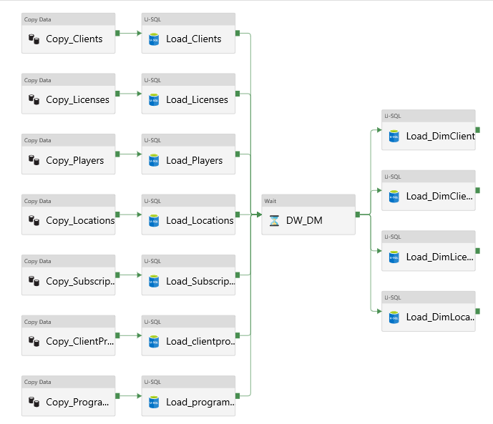

**Misc Tasks**

**Notes for next week**

* Outstanding tasks for next week
  + Finalize presentation for Subaru
    - Meeting dates Wednesday (afternoon), Thursday(all day)
  + OSS Reporting for Nissan
  + Automated Online/Offline reporting for Subaru (interim)
  + Feature Reporting SDS (not automated)
  + Standard weekly reporting